POM

Lab Innovation repository in PIM

Change request: R231018_000022 ​

Functional & Technical Specifications

|  |  |  |  |
| --- | --- | --- | --- |
| Version | Description | Author | Date |
| v0-1 | Draft | Christelle Zalisz | 17/11/2023 |
| v1-0 | Init | Coopman Eric | 15/12/2023 |
|  |  |  |  |
|  |  |  |  |
|  |  |  |  |
|  |  |  |  |

# Functional requirements

## Business needs – PIM configuration

The Roquette Innovation process is led by Marc Ravon, Head of customer Innovation. The purpose of this process is to launch Roquette innovating product on the market.

This innovation process has several steps and at the final step (before an official commercial launch with a material code), some sales funnel activites need to be conducted and follow up in Salesforce.

The Lab Inno product at a pre commmercial steps need to be part of PIM prodcut catalog in order to send the product information to Salesforce.

A Lab Inno repository has been created in PIM :

Lab Inno product are just listed under the repository Innovation, there is no tree structure.

There is no limited access requested for this new repository.

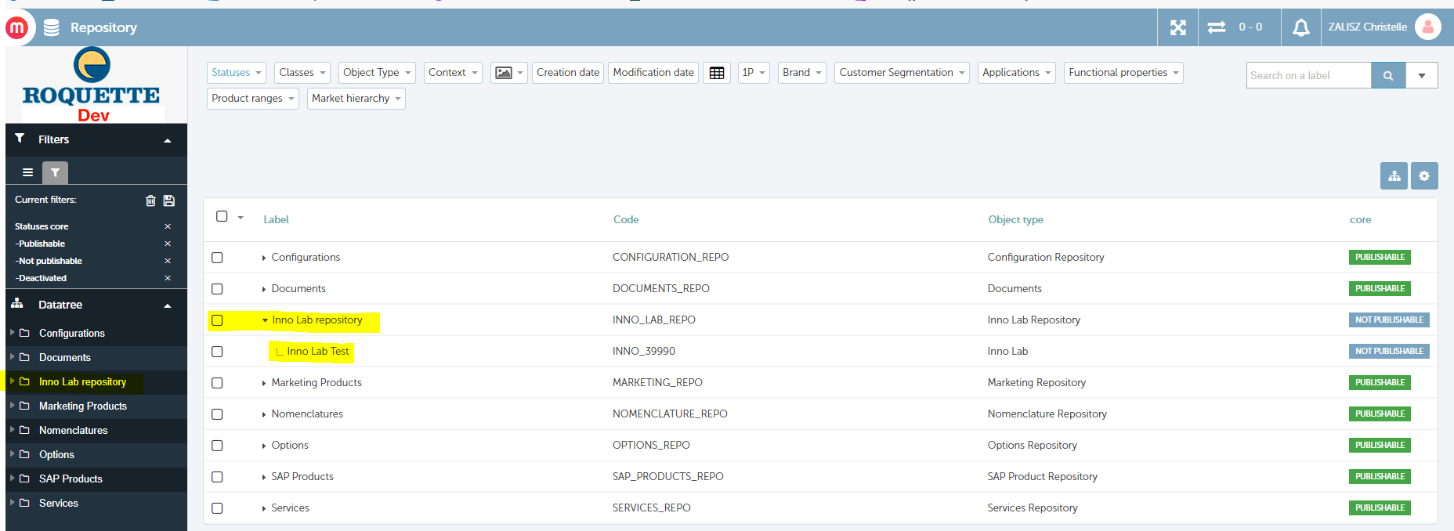

Lab Inno product has few attributes to be enriched by Innovation team.

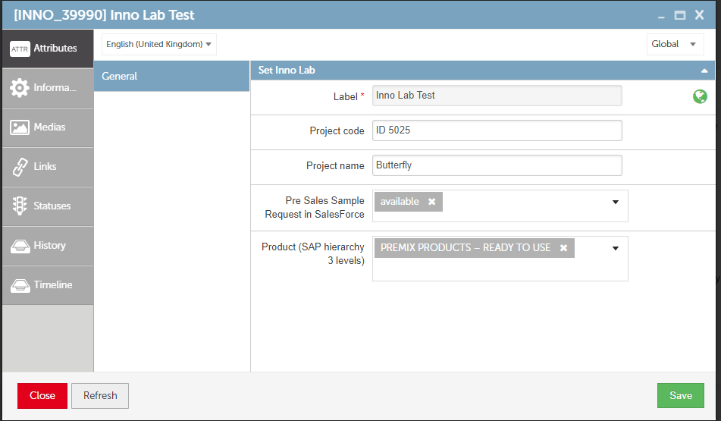

A full data initialization will be provided by the business. At the data initialization, the value pre sales sample will be “with approval”.

## User rights – New group “Innovation”

A new group Innovation based on AD group **AGORA_UO_80002377_IN**  has been added in PIM account parameters configurator module in management of users group.

Access right:

Group Innovation : Create – Read – Update on Lab Inno repository.

In order to inform Sales about products from the Innovation process, a tag Inno will be displayed on CPSO product page list and product page.

## Lab Inno repository products added to Map’s- Salesforce product flow

In Map’s – Salesforce product flow, add the Lab inno product.

Salesforce Pre requisite :

* Create a new product type
* Configure new field for Lab Inno product field

# Impact & Modification

# Technical Specifications



We have an extraction program to feed Salesforce with 3P updated in Maps.

The program runs on daily basis.

We would like to update this program to insert this new repository “Inno Lab repository”.

As for 3P, only inno lab products updated during the last 24 hours will be sent to Salesforce.

Here are the field to send to Salesforce usin,g product2 (in Salesforce):

1. ProductKey__c (Maps code):

* Mandatory - Inno lab product code

1. Name (Label):

* Mandatory - 255 characters

1. ProjectCode__c (Project code):

* this field can be empty: 255 characters.

1. ProjectName__c (Project name):

* this field can be empty: 255 characters.

1. SampleAvailability__c (Pre Sales Sample Request in Salesforce) (list of 3 values):

* this field can be empty
* AVAILABLE
* NOT_AVAILABLE
* UNDER_CONTROL

1. Parent__.ProductKey__c (Product (SAP hierarchy 3 levels)):

* this field can be empty: no parent (orphan)
* or we can select first level: SAP Family
* or we can select second level: SAP Subfamily
* or we can select third level: SAP RGC

1. HierarchyLevel__c : picklist – use the value INNO_LAB (Inno Lab)